- Download kidsblock，as shown below;
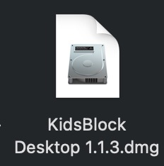
- Double-click KidsBlock icon，then drag 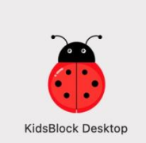 to the Applications folder.
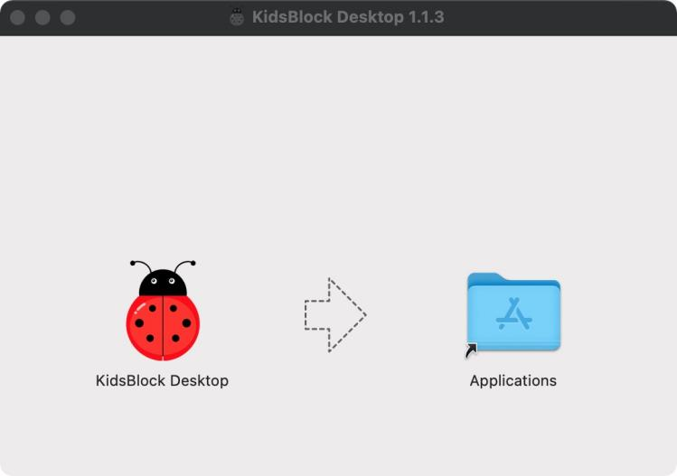
After the installation is finished, you will view KidsBlock icon.
